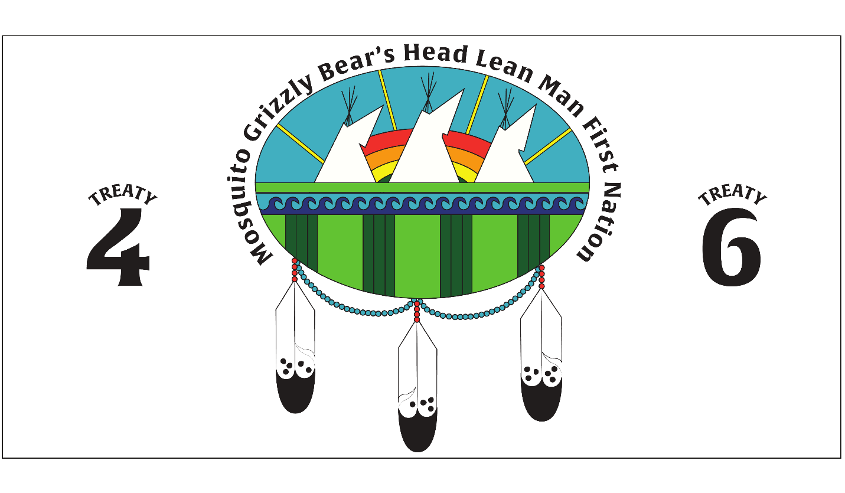

POST SECONDARY STUDENT SUPPORT PROGRAM

APPLICATION FOR FUNDING

Application Deadline Dates:

FALL TERM: June 30th
WINTER: October 31st
SPRING/SUMMER: February 28th

DATE___________STUDENT NAME _____________________

MOSQUITO GRIZZLY BEARS HEAD LEAN MAN FIRST NATION
Post-Secondary Application

PRIVACY ACT STATEMENT
*************************************************************************************************************
The information you provide in this application is for the purpose of administering post-secondary financial assistance. Personal information that you provide is protected under the provision of the PRIVACY ACT.
*************************************************************************************************************
It is important that you complete each section of the application thoroughly and understand the expectations that you must meet as a Post-Secondary Student. If at any time you are not sure of the process please contact the Post-Secondary Coordinator at (306)937-6120 Ext 228 or toll free at 1-866-937-6120 Ext 228.
It is your responsibility and is important that you complete all forms and have made all necessary arrangements with the eligible training institute of your choice so that all requirements for enrollment and class registration are completed on time and accurately.
PLEASE NOTE: Sponsorship for Post-Secondary Programs is limited.
All efforts to secure sponsorship will be made for students. However, students applying
For sponsorship are not guaranteed to have any or all their sponsorship requests met.

It is necessary that the applicant has enclosed the following information upon applying:

______ Funding Application

______ Letter of Acceptance/Conditional Acceptance from training institution

______ Copy of Status Card or letter of membership verification

______ Copy of you and your family’s health cards

______ Copy of High School Transcripts or of latest institute

______ 1st Year Students must include a one page Statement of Goals

_______ Returning Students must put in a one page letter regarding your academic
Plan for your remaining funding months

_____ IF THIS IS A CAREER CHANGE Please state on a one page letter why you have changed careers. Please note that all career changes will be treated as new applications.

*** Please note – applications will not be processed until all information is received ***

MGBH LM FIRST NATION Post-Secondary Application

To be eligible to receive sponsorship under the terms of the Mosquito GBHLM First Nation Post-Secondary Program, it is necessary that all applicants meet the requirements:
PLEASE READ CAREFULLY
Eligibility
- Applicants must have a grade 12 or mature student equivalent Grade 12 GED
- The program must require a minimum grade 12 entrance or mature student equivalent. (Please submit program information)
- The program must be one academic year in length (as defined by the institution)
- Students must be enrolled and accepted to the University or Institute of Training in the program of their choice.
**Applications will be deferred if students do not apply before application deadline or if number of eligible applicants exceeds the budget. This is in accordance to the policies set in the national guidelines
Types of Assistance
- Tuition – students’ tuition will be paid. Student will receive funds for textbooks and mandatory fees which are listed as requirements by the institution of study.

- Living allowance will not exceed the amount set out in the budget. Where students attend a foreign institute, this will not exceed the maximum levels in Canadian funds.

- Part-time students may receive assistance for tuition and the cost of books and mandatory fee only which are required by the institution of study.
Limits of Assistance
- Level I - Community College and CEGP Diploma or Certificate Programs

- Level II - Undergraduate Programs (University). These programs will lead to a degree. The programs are three or four years in length

- Level III - Advanced or Professional degree programs (Masters). These programs are twenty-four months in length

- Level IV Doctoral Programs

MGBH LM FIRST NATION Post-Secondary Application

New Student Returning Student Career Change Extension
PERSONAL INFORMATION

Name: _______________________________________ Date of Birth: _________________
Surname First Name Middle Initial Year Month Day

Study Address:

___________________________________________________________________
Box / Street Town /City
___________________________________________________________________
Province Postal Code

Telephone/ Cell ( ) _____________________ Email: ____________________________

Status Number (10 digits): ______________________

FAMILY STATUS

Single: ______ Single Parent: _____ Married: _____ Common-law: _____

Spouse: _________________________________ Band: ______________________________

Number of Dependent children residing with you: _________
Dependents:
Name | Age | Do they reside with you?

PERMANENT ADDRESS

Address: ______________________________________________________________
Street/Box # City

____________________________________________________________________________________________
Province Postal Code

SECONDARY EDUCATION INFORMATION

Last Grade completed: __________ Year completed: __________

Name of School: _______________________________________

Location: _____________________________________________

Have you previously been sponsored by the Mosquito Grizzly Bear’s Head Lean Man First Nation Post-Secondary Student Support Program? YES NO

PREVIOUS POST-SECONDARY EDUCATION (COLLEGE OR UNIVERSITY)

PROGRAM NAME/LEVEL | INSTITUTE | CREDENTIAL ACQUIRED | COMPLETION DATE
*use back for additional information

MGBH LM FIRST NATION Post-Secondary Application

CURRENT POST-SECONDARY EDUCATION INFORMATION

***PLEASE INCLUDE A LETTER OF ACCEPTANCE FROM THE INSTITUTION***A COPY OF YOUR REGISTRATION**TRACKING SHEET**
I hereby make application for educational assistance to attend:

Institution: | Location:
Program of Studies: | Start Date :  End Date :
Area of Study (Major/Minor): | Method of Delivery (Classroom/Distance/Online…)

Current year of study in program (Returning Students only): ___________________________

Attendance: Full time _____ Part time ____ _____ Session/Hours/Week

Have you been required to discontinue from any program in the last 2 years YES NO

If yes, please state the reason(s): _________________________________________________

____________________________________________________________________________

Type of Institute:

- University Undergraduate Degree (BA)
- Technical or Trade University Ph. D (Masters)
- Community College (Diploma) College Preparation
- Private Institution

Academic Career Plan

Please describe your long term goal(s): ____________________________________________

____________________________________________________________________________
____________________________________________________________________________
____________________________________________________________________________

____________________________________________________________________________

____________________________________________________________________________

____________________________________________________________________________

____________________________________________________________________________

___________________________________________________________________________

___________________________________________________________________________

__________________________________________________________________________

__________________________________________________________________________

__________________________________________________________________________

__________________________________________________________________________

__________________________________________________________________________

MGBH LM FIRST NATION

RELEASE OF AUTHORIZATION

I hereby authorize any information concerning my academics such as Registration and / or Mark Transcripts be released upon request to the Mosquito Grizzly Bears Head Lean Man First Nation Post-Secondary Coordinator.

Student’s Name (please print): _______________________________________________

Student’s Signature: ______________________________________________

Student #: _______________________________________________

Institution: _______________________________________________

Program: _______________________________________________

Term / Semester _______________________________________________

MGBH LM FIRST NATION Post-Secondary Application
Mosquito Grizzly Bear’s Head Leanman First Nation Post-Sec Education Direct Deposit

Name: _______________________________________________

Address: ___________________________________________________

Telephone: ____________________________________________

Name and Address of Bank: _____________________________________________________________

Bank Telephone: ________________________________________________________________

Institution#: (3 digits):________________________Transit # (5 digits):____________________________

Account #:_____________________________________________________

Type of Account: _______________________________________________________

ALL INFORMATION WILL BE KEPT STRICTLY CONFIDENTIAL

***PLEASE SURE TO SEND IN ALL THE REQUIRED INFORMATION, IF YOU ARE NOT SURE PLEASE CALL YOUR BANK AND INQUIRE WITH YOUR BANK REPRESENTATIVE.
INCOMPLETE OR INCORRECT INFORMATION CAN CAUSE DELAYS.

If you have a chequing account please attach a blank cheque (marked VOID)

I HEARBY AUTHORIZE MOSQUITO GRIZZLY BEAR’S HEAD LEANMAN POST SECONDARY EDUCATION TO DIRECTLY DEPOSIT INTO MY BANK ACCOUNT AS NOTED ABOVE.

________________________________________________________________________
Signature Date

PRIVACY ACT STATEMENT

The information you provide in this document is for the purpose of resourcing and administering Post- Secondary Financial assistance. Personal information that you provide is protected under the provision of the PRIVACY ACT.

