|  |  |  |
| --- | --- | --- |
| February 2023 |  | NEWSLETTER |

MOSQUITO GRIZZLY bEAR’S hEAD LeAN MAN fIRST NATION

 

# **Vision**

***CHIEf Tanya aguilar-antiman***

***councillor brad starchief***

***COUNCILLOR SANDY WAHOBIN***

***COUNCILLOR CELEST SANDERS***

***COUNCILLOR DEBORAH STONE***

***COUNCILLOR TRISTAN BIRD***

Mosquito, Grizzly Bear’s Head, Lean Man First Nation supports a long-term vision of healthy individuals, families and community achieving self-sufficiency and self-sustainability.

**MISSION**

The Mosquito, Grizzly Bear’s Head, Lean Man First Nation provides leadership in the development and provision of necessary social and health programming for our constituents; continuously builds and implements an economic plan that creates wealth, builds infrastructure and seizes growth opportunities at the community level on behalf of our First Nations; and honors our unique culture, language and history by preserving and actively participating in our First Nations heritage

**Director of Operations**

**Community Compressive Navigator**

Hello.  It has been an honor and privilege to work for my home community, I’ve been with the Nation since April 2013 and Director of Operations since May of 2015.  I’ve committed my time and energy on my own Nation to build upon all aspects of administration. We serve you to fulfil our vision of creating healthy families and individuals and becoming a healthy, prosperous community.  We work on progressing our accountability and transparency through various forms of communication.  We work towards revitalizing our Nakoda/Cree heritage by providing opportunity for cultural implementation.

I am proud to lead by example by choosing a drug and alcohol-free lifestyle to better my life and the lives of my children. I sew, bead, powwow dance and I enjoy making memories by being active with my children in family activities and cultural ceremony. I strongly believe and promote that Culture saves lives and we must as Indigenous people’s grasp onto our language and cultural lifestyle!

Thank you.

Michelle Daniels

I have been a CCP Navigator since 2018 with MGBHLM, helping promote activities of all sorts such as Elders Dinners, Roundance’s, Pow-wow’s Etc., working closely with Chief and Council and all program Directors including Michelle Daniels to get good direction on where they would need my assistance, on promoting Healthy life styles within the community.

I assist on bringing Workshops and Guest Speakers to the nation that would initiate awareness to the work place and people, with teachings on every aspect of life, leading the way on activities for our Elders as well as the Youth, offering my assistance in decorating for special functions being set up in our community or where ever the events are taking place, so that our people can take pride in the event that is being hosted!

Also being the one our people could reach out to for the Indian Day School application assisting anyone who needs guidance. Then working with staff to help encourage Lateral Kindness. I’d also like to proudly say I have gathered information and data for the CCP book that will be launched in the near future.

Furthermore, I have been honored and privileged to work for my Nation I take great pride in what I do for my people and community. I hope that the New Year will bring us triumph and that we all come together twofold to enjoy one another’s company in the events that 2023 will bring to the table may you all be blessed in 2023, I’ll be looking forward to working with you all as a Nation alongside with you.

HIY HIY, Panymaya

POST SECONDARY STUDENT SUPPORT PROGAM

INTAKE DATE WAS OCTOBER 31, 2022

FOR WINTER TERM FUNDING.

Must have GRADE 12 Diploma to apply

List of Designated educational institutions across Canada that are eligible with ISC

[www.CanLearn.ca](http://www.CanLearn.ca)

**Website Information**

<https://www.northwestcollege.ca>

Meadow lake/N.B North West College- Application Portal

[www.usask.ca](http://www.usask.ca)

admissions.usask.ca Recrutiment and admisssions

[www.siit.ca](http://www.siit.ca)

N.Battelford, Saskatoon, Regina, Prince Albert Sk

[www.https//saskpolytech.ca](http://www.https//saskpolytech.ca)

A-Z list of pograms Sask Polytechnic

[www.uregina.ca](http://www.uregina.ca)

Univeristy of Regina campus

[www.fnuniv.ca](http://www.fnuniv.ca)

First Nations of Canada

<http://www.lakelandcollege.ca>

Lakeland College Lloydminister

“Education is the most powerful weapon which you can use to change the world.” ~ nelson mandela ~

Mosquito, Grizzly Bear’s Head,

Lean Man First Nation

Post-Secondary Visits

Post-Secondary Policy Overview and Survey

Meet and Greet with Students

January 17th, 2023-North Battleford, Comfort Inn 5-8pm

January 18th, 2023-Saskatoon, Ramada 5-8pm

February 3rd, 2023-Calgary, Grey Eagle Resort 5-8pm

* This will give students a last chance to print off their marks from the Fall Term and submit them to Jaqueline, laptop and printer will be available for students.
* If you have not submitted your Fall Term marks, please do so as you will not receive your February funding until they are sent in.

Lots of door prizes for students who attend and fill out the survey.

**Director of Education**

Tansi everyone! Let me introduce myself, my name is Kari Checkosis and I’m the new Director of Education for MGBHLM First Nation. I’m so grateful for the opportunity to come back to my home community. My job is to overlook Mosquito School and ensure that it is a fun and exciting place for learning and growing for both staff and students. I also look after the Mosquito Daycare which is under new Supervision. The Daycare is looking for spots to fill 3 Full Time and 3 Part Time. Daycare Hours are from 8am-4:30pm Monday to Friday. I am looking forward to getting into the community and partnering up with other organizations to provide some great programming for our youth. If you have any questions or concerns, please feel free to call me or to come and see me at the Band Office.

Sincerely,

Kari Checkosis

MGBHLM Director of Education

**Important Date:**

Community Education Meeting, Thurs. Jan. 26th at 5pm

**Job Opportunity**

We will also be looking for EAs for Mosquito School:

1 Full Time EA for ELA Support

3 Full Time EA’s (Early Learning, Middle Grades)

c

**Indian Registry Administrator (IRA)**

*Intro:*

Tansi, my name is Nadine Moosomin, I am the new Indian Registry Administrator here in Mosquito, Grizzly Bear Head, Lean Man, I recently started back in the beginning of October, got my training done the end of November 2022. I feel honored to have this job and hope to keep up with every bit of it, keep you guys proud and happy that I can accommodate all needs for all individuals that comes with my title.

I had the opportunity to join the Christmas Distribution in December, I was so happy to meet our relatives out of Province and in the States. Throughout the trip I was able to issue status cards and get applications done.

Came back and did the same for our community, we are out of cards but will be receiving more hopefully by end of January.

**Now let’s talk business:**

* **Indian Registry days are Tuesdays & Thursdays**

**Parents:**

If you haven’t registered your child or need to fill out forms, please come see me on every Tuesday’s and Thursday’s so we can discuss the eligibility for registration and prepare to fill out the forms.

**Steps with processing application**

* You will need your child’s **Birth Certificate** (long form)
* Complete an application for registration form and submit the original from (signed by both parents) along with the original document for processing.
* Await correspondence from INAC regarding application status, once the registration is complete, INAC will send you a letter of confirmation of registration.

*\*Original Birth Certificate must be sent not a photocopy; the original will be sent back to you only if your address is your current address on application.*

**Info on Birth Certificates**

I do hold forms and can help you fill them out. I do not process them yet, we have BATC worker Jeremy Spyglass processing them and sending off applications when he does have time.

You can order Birth Certificates from **eHealth** Saskatchewan: <https://www.ehealthsask.ca/residents/births/Pages/Order-a-Birth-Certificate.aspx>

* If you do order online, you must have a valid credit card.
* Please order the **long form birth certificate** as it states the parent’s names and is a must for Indian registry requirement.

**Status Cards:**

* Please bring one piece of valid ID, with person’s name, date of birth, residence, and picture, or piece of identification with signed guarantor form with guarantor’s signature and persons info.
* Applicants that are 16 years or older must sign their own applications.
* Applicants between ages 12- 16 have the option of a parent or legal guardian signing for them.
* Applicants under 12 must have their parents or legal guardian sign the application.
* Person can only carry one Treaty Card at any given time.
* Only 2 cards can be made for one person for one year.
* Fees for cards are no charge to Mosquito band members, there is a **$10** fee for non-band members.

(Fees go to supplies used)

**Band Transfers:**

* ***Unfortunately, we are not taking in any transfers, to be determined when we will be accepting, sorry for any inconvenience!***

I thank you for your time and for all your patients with me, as this is so new to me.

This to me has been a great opportunity and will continue to do my best to cater to the community and band members.

**HIY HIY,**

Nadine Moosomin  
 Indian Registry Administrator

**Human Resources**

Tansi,

My name is Quincy Littlewolfe I am the new Human Resource Manager my first day of employment with MGBHLMFN was on December 12/2022, I look forward in working with the community, Chief and Council, Sr administration, and Director of operations, my objective as the Human Resources manager is to work in collaboration with Chief and council Directors, Managers and Staff. To build a positive working environment and organizational culture. This position supports Mosquito GBHLM mission through the development, implementation, and coordination of variety of human resources services and programs including those affecting employment, labour and employees’ relations, compensation, recruitment, training and development and the development of policies and programs. This role provides direct supervision and guidance to all human resources department Staff ensuring all policies and procedures approved in a place within the First Nation, are enacted and enforced, and that staff conduct themselves in a professional, efficient, and effective manner in carrying out the business of the First Nation. I look forward in working with the First Nation if you have any questions feel free to drop in at the administration, I will be happy to answer any questions you may have.

If you’re looking for employment look at the mosquito app new employment opportunities are updated

*"Human resources are like natural resources; they're often buried deep. You have to go looking for them; they're not just lying around on the surface."*

Thank you,

Hiy hiy

**Social Development Newsletter Update**

**January 2023**

Tansi MGBHLM members, my name is Elsa-Mae Moosomin, and I am currently the coordinator of Social Development/Social Assistance for Employment and Training (SAET). I took on the role as of September 19, 2022. Nadine Moosomin is my helper as she has something exciting to announce for herself.

Income Assistance is here to provide “temporary assistance” while you seek for employment or want to take a program. Through SAET I can assist with confirmation of an employment/acceptance letter. If you have barriers that prevent you from doing so, please do not hesitate to contact myself or our Personal Development Coach (Jeremy Spyglass) to address your barriers and help you reach your goal.

How to apply! Bring 2 valid government Identification Cards, 3-month bank statement, and a direct deposit form. There is a 7-10 business day wait for the Service Canada cross check to be mailed back.

Soon it will be mandatory to receive your assistance via direct deposit. For those who receive IA, expect it on the 1st of the month or 15th, if those land on

weekend it would be the Friday or Monday depending on the date.

I am proud to say we had 6 successful graduates that took home certificates going towards Esthetics. They finished in August 2022.

There is currently a Home Builders Program being held at The Ridge in Battleford from December 4,2022 – March 24/2023. The students will learn Home Construction from start to finish. Framing techniques, Floor/Wall construction, Exterior/Interior finishes. Trained to be Carpenter helpers, and possible employment with the Economic Development Construction Crew when completed training. This is exciting as it can start off your career path. I hope to bring it back again so we can build more homes for our nation, or to start your own journey to become a leader in construction.

Thank you for allowing me to serve the nation. You can contact me at the band office 306-937-6120 if you need to have a chat.

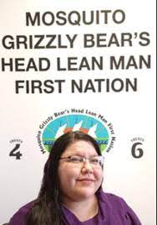

**First Nation Representative Services** Support First Nations to have a voice when children, youth and families from their community are involved or at risk of involvement with the Child and Family Services System. First Nations Representative services are critically important to First Nations and to ensure that the rights of First Nations children and youth are respected within the child and Family Services system.

The role of the First Nations Representative service will be First Nations-defined and may include engaging with child and family service providers and participating in family service matters as set out in provincial, territorial and federal child family services laws.

Good day, my name is Denise Lynne Spyglass and I was the Human Resources Manager from October 21, 2019 to November 24, 2022. On November 25th, 2022, Chief and Council decided to put my many years of experience as a Social Worker to good use. As of Nov 25th, 2022, I will be the new First Nation Representative Services Support Worker.

Since starting my new position, I have been planning out what will be the best way to roll out this new Prevention Program. I will rely on Chief and Council for direction, updates and recommendations. I will be also seeking out community support and to find out from our community members on how you would like to see this program run.

Mosquito Grizzly Bear’s Head Lean Man First Nation Chief and Council is dedicated to keeping our children in our community and I love that! We believe that we are the best providers for our own children, they are our future.

## **We are growing and we want all our children to be a part of our community! There are so many benefits to helping our children stay in our community and growing up right here in our community! This is an exciting time, and we need your input in order to make a difference!**

We will be having Workshops to help explain this program and we will invite you to come and share a meal and be formed about the new Prevention Program and what it will do for our community!

This is exciting! Come join us and help build our community, our future, and the future of our children!

Exciting opportunities lay ahead!

**“WE MUST PROTECT FAMILIES, WE MUST PROTECT CHILDREN, WHO HAVE INALIENABLE RIGHTS AND SHOULD BE LOVED, SHOULD BE TAKEN CARE OF PHYSICALLY AND MENTALLY, AND SHOULD NOT BE BROUGHT INTO THE WORLD ONLY TO SUFFER”**

**Housing Department**

Tansi,

Here is what is happening in the Housing Department. As you all know, housing is one of the biggest areas of concern on the First Nation as many families want to move home, homes need renovation and overcrowding. The Chief and Council, along with staff, are working hard to make changes to this area. Remember that this is not going to happen overnight as funding is the key issue.

We are working on applying for a grant to build 30 new homes within the next 24 months. There are dead lines that we have to accomplish to have it altogether to submit the application.

This spring we are working on a new subdivision for the First Nation with approx. 40 lots to be serviced and this is an approved Capitol Project initiative. They will not be side by side as we will try to make

the yards big. Each house on the First Nation is allowed to have renovations completed to the house to the amount of $15,000.00. The Band will pay home hardware for all the materials and pay for the labour, but it all has to be within the amount of $15,000.00. If you have someone to do the work that is a skilled carpenter, they will get paid once the work is done.

We are working to try and make your lives easier on the First Nation but please be patient with us as we can only do what we can do to make all the difference. Working together is the key to success, your help is needed to make it all a reality.

For contact phone Band Office 306-937-6120

Milton Oxebin (306)250-5108

Housing Manager

Nikeda Stone

Housing Clerk

**Mosquito Health**

Tansi MGBHLM Band Members

I’d like to extend best wishes to all Mosquito, Grizzly Bear’s Head and Lean Man members a very Happy New Year from all the Health Staff. It has been a privilege so far to be part of MGBHLM Nakoda/Cree Nation. Community Health and Wellness Strategic Plan is well under way with requirements by ISC (Indigenous Services Canada) – NIHB (Non-insured Health Benefits) as part of the multi-year work plan. Moving forward we are on a continuence to pursue those western ways and combine with the present traditional knowledge and languages hiy hiy.

MGBHLM Health consists of various programs such as:

* Community Health continues to schedule immunization, covid boosters, flu shots, children’s immunization & STI testing - supports ISC/Battlefords Agency Tribal Chiefs
* Water Quality monitored by Environment Health Officer (ISC) weekly
* Maternal Child Health – FASD (Fetal Alcohol Spectrum Disorder) & COHI (Children’s Oral Health Initiatives)
* Home Care do weekly schedule with clients
* Mental Health and Wellness
* Medical Transportation
* Jordan’s Principle

Sincerely,

MGBHLM Health Staff

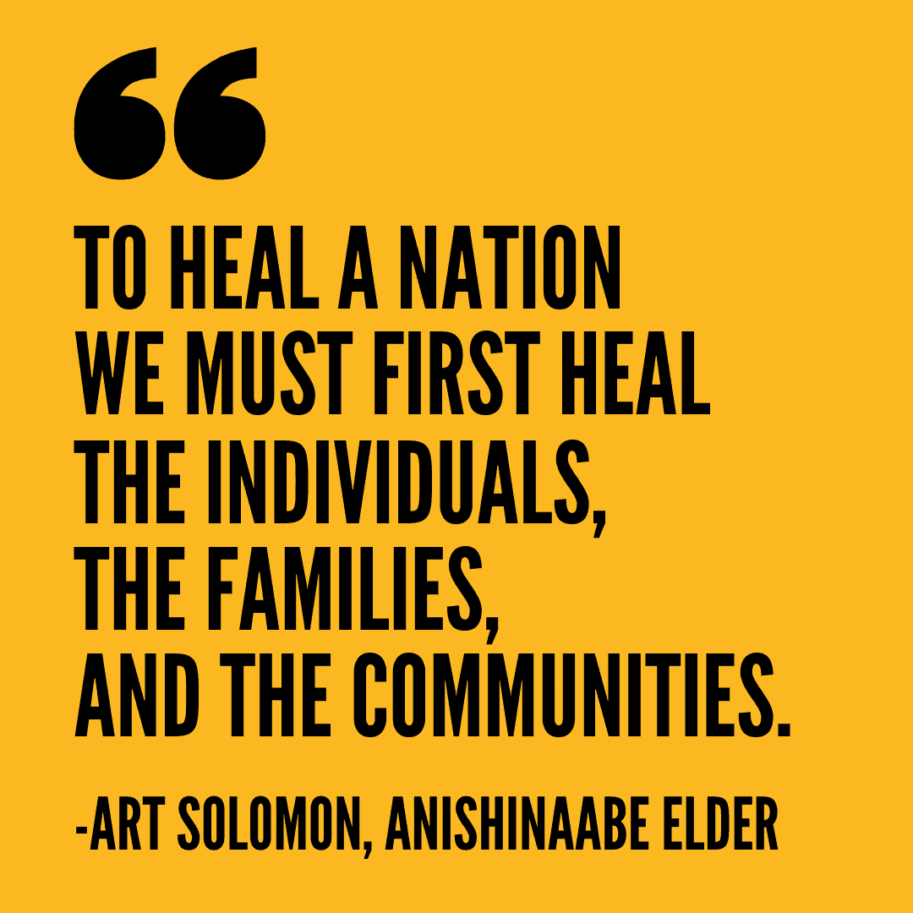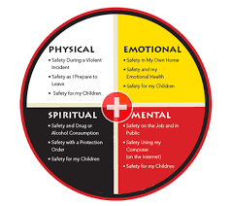

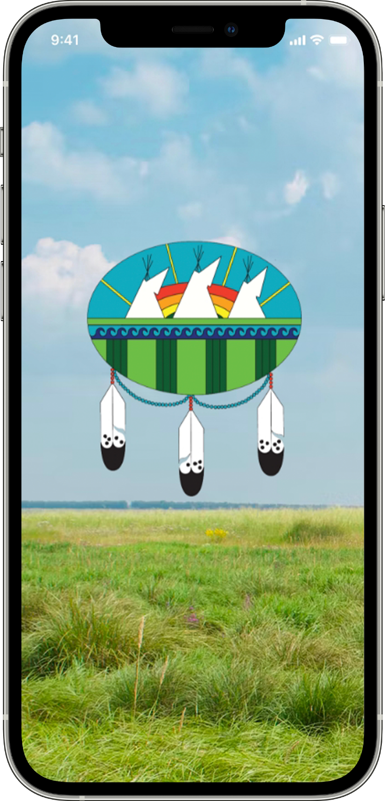**The Mosquito GBHLM App**

Peoples of Mosquito FN,

can download the App with

they’re mobile phones. The

Mosquito App informs the

community with up-to-date job

postings, upcoming events,

housing Applications and more

this is a new way for the community

to be connected with anything new

and exciting arising in the Nation.

**Steps on how to download**

1. **Go to your App store on your**

**Mobile device.**

1. **Search up Mosquito GBHLM**
2. **Download sign up and**

**register with your email**

1. **ENJOY! 😊**

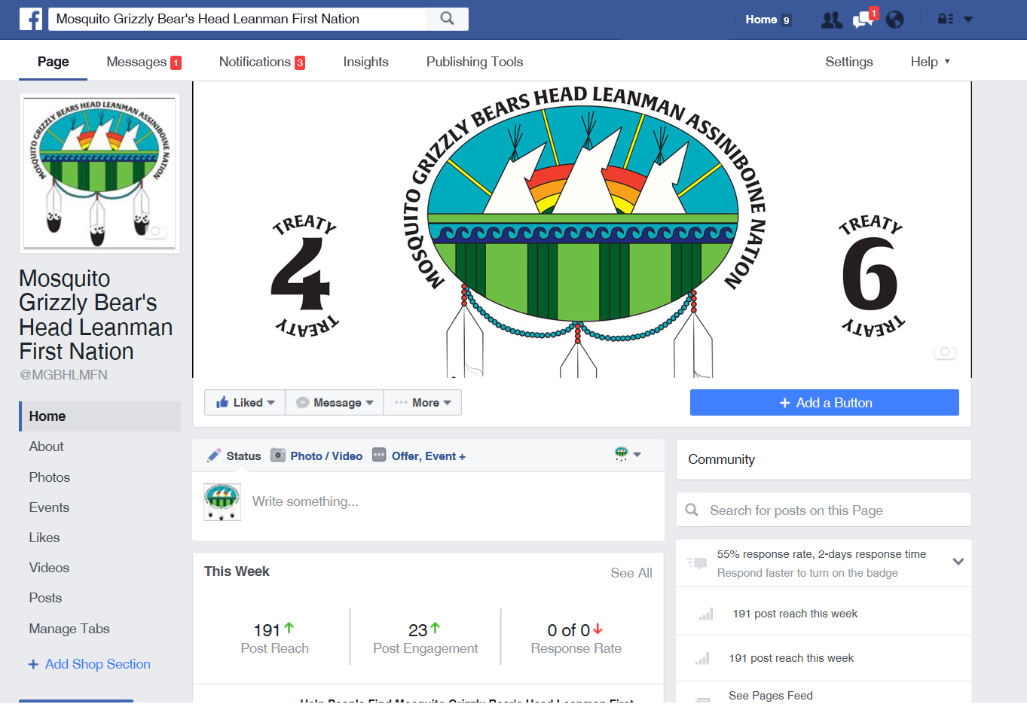

 

Like us on FB Message us on FB

Keep up to date on the happenings in the community through our Facebook page

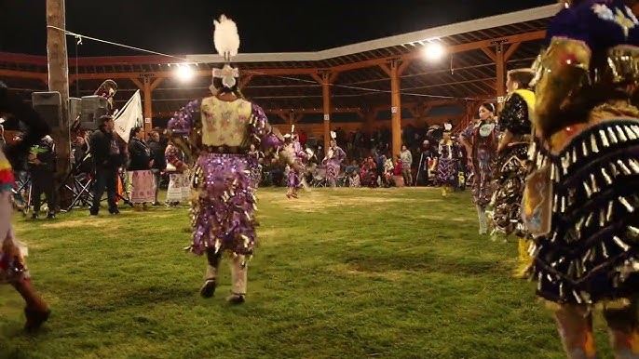Mosquito FN Powwow 2022

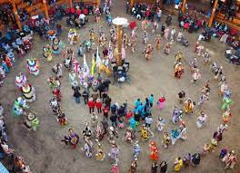

**Christmas Roundance 2022**

**Lateral Kindness week**

