VISION  Healthy and prosperous individuals, families and community achieving self-sufficiency  MISSION STATEMENT  To protect and implement Treaty #4 and #6 that will assist the Nation become self-sufficient, prosperous and improve members quality of life and preserve the culture, language and history. | Guiding Values  Respect - we acknowledge and treat everyone with dignity and respect  Honesty - we are true, honest and fair in everything we do faithfully  Accountability - we are accountable and responsible for all of our members and their assets  Unity - we work together as a team for the benefit of the Nation members  Contact Us  (306) 937-3149 Ext. 1  (306) 937-3063  P.O Box 177  Cando, SK S0K0V0  rose.moosomin@mosquitofn.ca  @MGBHLMFN | Medical transportation  Co-ordinator -  Rose M. Moosomin  306-441-3839  Taxi Driver -  Bradley L. Wahobin  306-441-3841
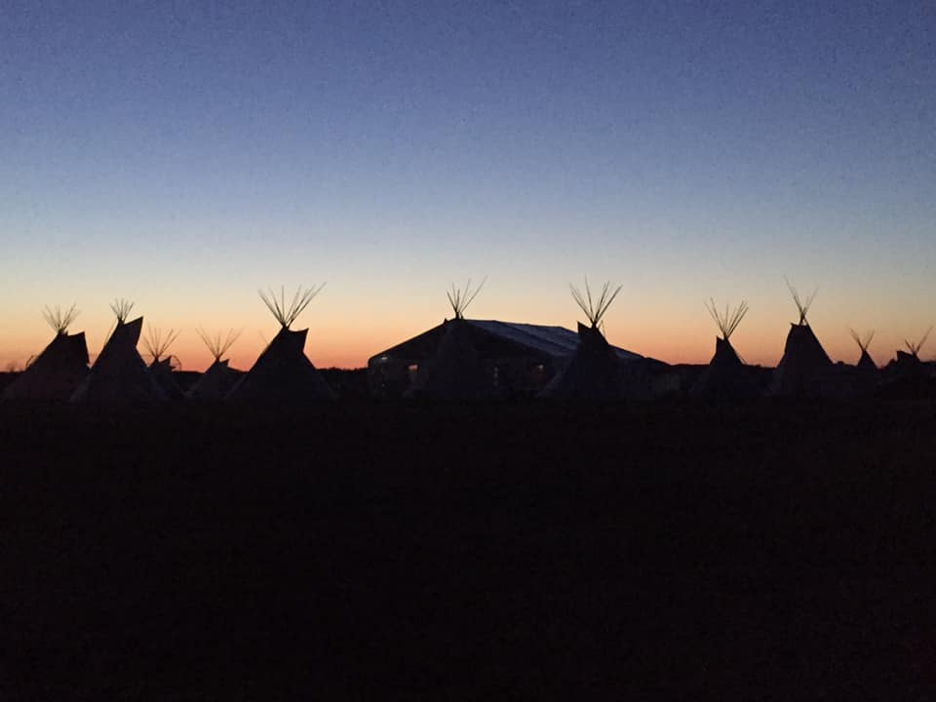  MGBHLMFN Nakoda Gathering 2019  MEDICAL TRANSPORTATION  Nearest Appropriate Destination  Non – Insured Health Benefits are provided for nearest appropriate facilities and the most efficient and economic destinations.  If a client has been referred beyond the nearest appropriate location, obtain confirmation of the referral either written or over the phone. This confirmation may be required as a supporting documentation for support of a request (escorts, room & meals). | Escort Criteria  - Where a client has a physical disability which requires help with activities of daily living.  - Where the Client is medically incapacitated.  - Where the Client has been declared “mentally incompetent”.  - For translating purposes.  - When the client is under the age of majority (18).  Destinations Approved  Jurisdiction for travel for our Community taxi is to the Battlefords, Unity, Wilkie and Saskatoon. This is according to the Contribution Agreement with Health Canada.  Private Mileage will be paid out if the taxi is not running to that destination.  He who has health, has hope; and he who has hope, has everything’.  Providers for Off First Nation Members  Band Members living off the First Nation is to call the NIHB (Non-Insured Health Benefits) for services providers such as for the private mileage, accommodations and meals,  Call Centre 1-866-885-3933 Ext. 1 | 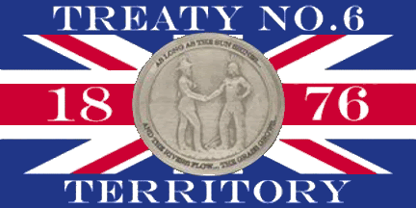  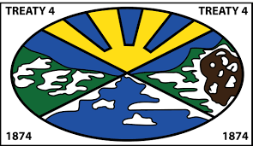  The Hospital Liaison worker is available for assistance at the Battleford’s Union Hospital 306-446-6600. There is time appropriate when the taxi is passing through the Battlefords to Saskatoon when resident pick up is available.  Methodone Program  At start of Methodone Program, eligible for 6 months of daily ingestion of methodone.  Clients who are on carries are not eligible for medical transportation assistance to pick up carries.  ADDICTIONS TREATMENT TRAVEL POLICY  Travel will be funded to the closest appropriate funded/referred facility in the home province only. Exceptions are made to travel outside the province only when the required treatment is not available and approved by NIHB.

