VISION  Healthy and prosperous individuals, families and community achieving self-sufficiency  MISSION STATEMENT  To protect and implement Treaty #4 and #6 that will assist the Nation become self-sufficient, prosperous and improve member’s quality of life and preserve the culture, language and history. | Guiding Values  Respect - we acknowledge and treat everyone with dignity and respect  Honesty - we are true, honest and fair in everything we do faithfully  Accountability - we are accountable and responsible for all of our members and their assets  Unity - we work together as a team for the benefit of the Nation members  Contact Us  (306) 937-6120  1(800) 937-6120  (306) 937-3678  P.O Box 177  Cando, SK S0K0V0  glenda.bird@mosquitofn.ca  @MGBHLMFN | C.C.P Navigator  Glenda bird
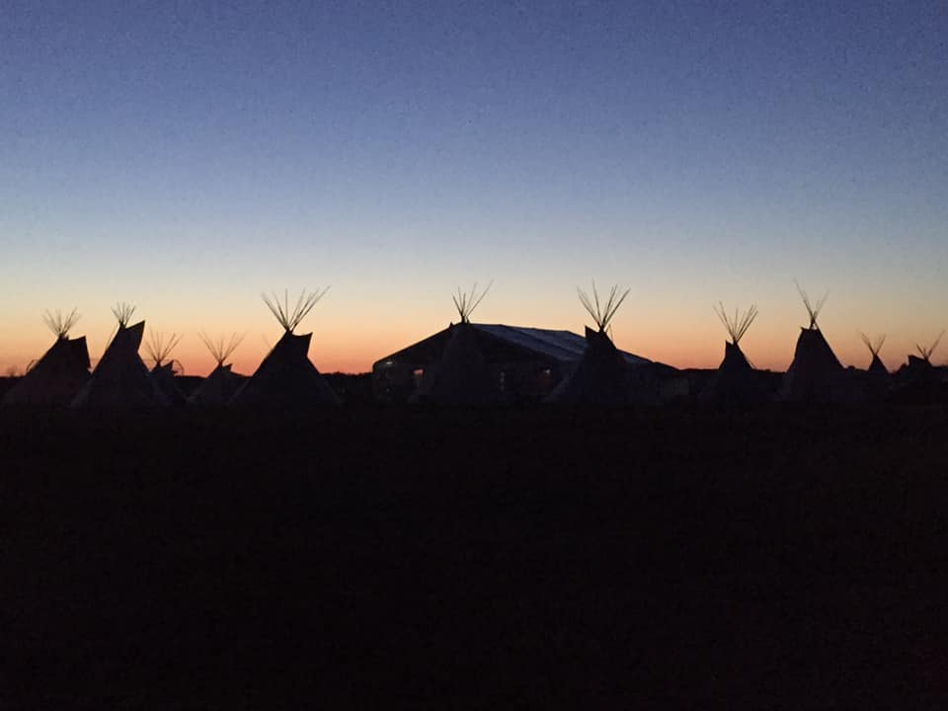  MGBHLMFN Nakoda Gathering 2019  PROGRAM SERVICES  Comprehensive Community Planning is a way of embracing change and planning a better future for the Community.  It can help our individual First Nations make a positive difference in addressing the specific issues of our Community.  CCP also includes funding, educational and planning resources to support the development and implementation of our Community’s plan. | Solutions:  To work alongside Chief and Council and all Band Membership. Hearing and meeting the needs and wants for our First Nation members as to:  Cultural Activities  Youth Activities  Elder Involvement  Community Involvement  “I have seen our community grow and be more responsive in community wellness and cultural events. I have seen our youth involve themselves in these events and outpour with hunger for more positive changes.”  “There has been a very positive response for our community members in every aspect.”  “Healing Is the Start for our Nation.”  “And it has begun”  CCP Navigator  Glenda Bird | Meeting the Dreams of Our Nation In:  Housing  Community Wellness  Community Functions  Cultural Engagements  Healing Lodges  Pow wow’s  Roundances  Talent Shows  Elders Dinners  Youth Activities  Infrastructure  New Store  Gravel Pit  Land Claims  Employment  Security Company  Workshops

