VISION  Healthy and prosperous individuals, families and community achieving self-sufficiency  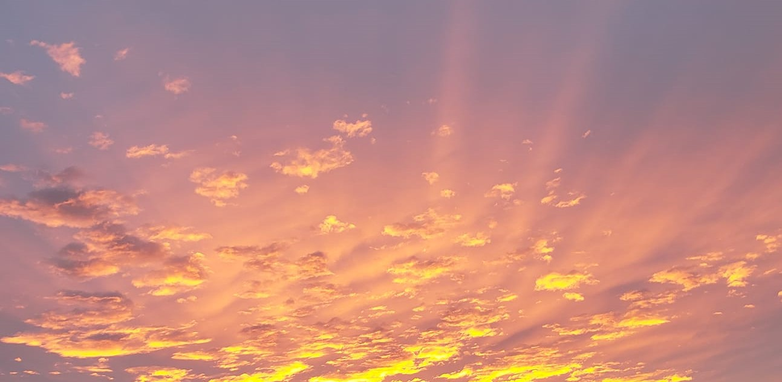  MISSION STATEMENT  To protect and implement Treaty #4 and #6 that will assist the Nation become self-sufficient, prosperous and improve members quality of life and preserve the culture, language and history. | Guiding Values  Respect - we acknowledge and treat everyone with dignity and respect  Honesty - we are true, honest and fair in everything we do faithfully  Accountability - we are accountable and responsible for all of our members and their assets  Unity - we work together as a team for the benefit of the Nation members  Contact Us  (306) 937-6120  1(800) 937-6120  (306) 937-3678  P.O Box 177  Cando, SK S0K0V0  Email: frankie.m oosomin@mosquitofn.ca  @MGBHLMFN | MGBHLMFN Housing  Frankie MOosomin
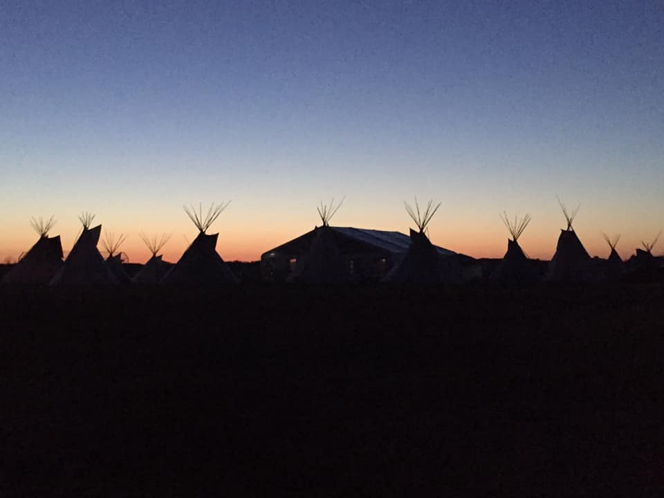  MGBHLMFN Nakoda Gathering 2019  PROGRAM SERVICES  MGBHLMFN Housing insists for Housing Tenants to reach out to the Housing Team for any needs and/or emergency’s which include plumbing, electrical and sewage backup. Make sure to come in and update your Housing Applications on an annual basis and to fill out your Maintenance Requests Forms. Have a great rest of 2019 and see you all in 2020! | CMHC SECTION 95 HOUSING  MGBHLMFN Housing has successfully been approved for Section 95 housing. We have 2 units for Phase 7 delivered. We will continue to work towards accessing CMHC Housing.  MGBHLMFN Housing Team:  Councillor- Kyle Stone  Clarence “Frankie” Moosomin  Arnold Moosomin  Mosquito Construction  On Call Emergency Number:  (306) 481-6121  After Hours Emergencies | 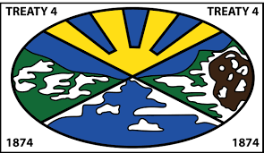  Reminder to bring in your Housing Applications, Maintenance Requests for furnace, plumbing and electrical. Call the office, Housing Staff are always available.

